DATA COLLECTION INSTRUMENT - MEASURES
Variability in Pattern Practice
Below are some example activities and questions for participants to complete during the session. All activities will be variants of the examples provided below.
Examples of pictures participants will see
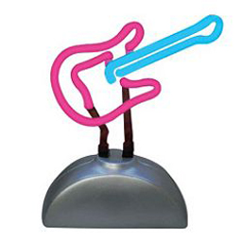
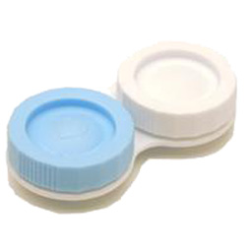
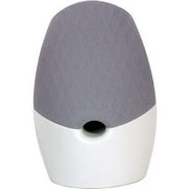

As shown in the sample pictures, they will be shown with daily life objects and try to recognize them later.
Examples of digits partipants will see
4
9
0
7
As shown in the sample texts, the digits they are asked to add together are within the 0-9 range.

